Status of the NESSI project.

L.A.Popeko, A.V.Cherny, G.A.Shishkina, L.A.Grigorieva.

The neutrino electromagnetic form-factor.
A search for neutrino-electron elastic scattering as a laboratory method of neutrino magnetic moment measurement.

- We expect to reach new fundamental information about weak interaction and intrinsic neutrino properties such as neutrino magnetic moment using the high precision measurement of the reactor neutrino-electron elastic scattering.
- In the first our experiment performed on 37.5-kg silicon detector, on Rovno reactor we have got upper limit of neutrino magnetic moment $μ_{ν}≤1\text{.}8×{\text{10}}^{−\text{10}}μ_{B}$. The cross section of antineutrino-electron elastic scattering in energy range of (0.6 - 2.0) MeV was measured as $σ_{\tilde{ν},e}=(1\text{.}\text{26}±0\text{.}\text{62})×{\text{10}}^{−\text{44}}{{\text{cm}}^{2}}/{\text{fission}}$.
- The reactor of Rovno electric power station is situated on the earth surface. Cosmic rays produce an activation of the detector and constructing materials around it. MUNU collaboration has the same conditions, they are going to measure $({\tilde{ν}}_{e},e)$-scattering on Bugey reactor (France).
- New measurement of $({\tilde{ν}}_{e},e)$-scattering has started on Krasnoyarsc reactor, which situated inside a mountain. We are going to work there in collaboration with Kurchatov Institute.
- Low background neutrino laboratory on Krasnoyarsc underground reactor is at the distance 18.5m from reactor core. Neutrino flux on the detector is $0\text{.}8×{\text{10}}^{\text{13}}{\text{neutrino}}/{{\text{cm}}^{2}}⋅\text{sec}$. Thermal power of the reactor is 1800 MW. The reactor company consists of 40 days - reactor ON and 12 - 20 days - reactor OFF, that supplies better conditions for background subtraction.

- New version of 80-kg silicon semiconductor detector and increased heavy shielding, situated in the vacuum chamber, is shown on Fig.1.

- A background conditions in the experiment and expected $(ν,e)$-scatted electrons spectrums are shown on Fig.2

A view of the set in the process of the test measurement in the neutrino laboratory of PNPI.

- The first phase of the experiment was finished in 1999. We studied a level of radioactive contamination of the plant, the technical possibilities of the transportation of the ultra low background technique to the Krasnoyarsc underground neutrino laboratory, a possibility of the montage and long time running in the vicinity of the reactor.
- The measurement of radioactive contamination in the laboratory, performed by germanium and silicon detector (no any shield), shows that artificial gamma-activity is on the level of natural one such as potassium and thorium.
- The background of the 80-kg silicon detector in heavy shield of 250 g/cm² estimated as 1200 c/day for energy range 50-2000 KeV. This is more one order of magnitude lower, then it was on the earth surface.
- Cosmic rays flux equal to 0.21/sec for all detectors. This is a factor 200 lower then for our experiment in Rovno and a factor 160 - for MUNU collaboration.
- The 4$π$-active shield consists of 125 scintillation detectors with dimensions: 500500120mm everyone.

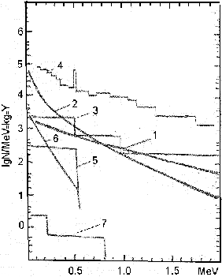
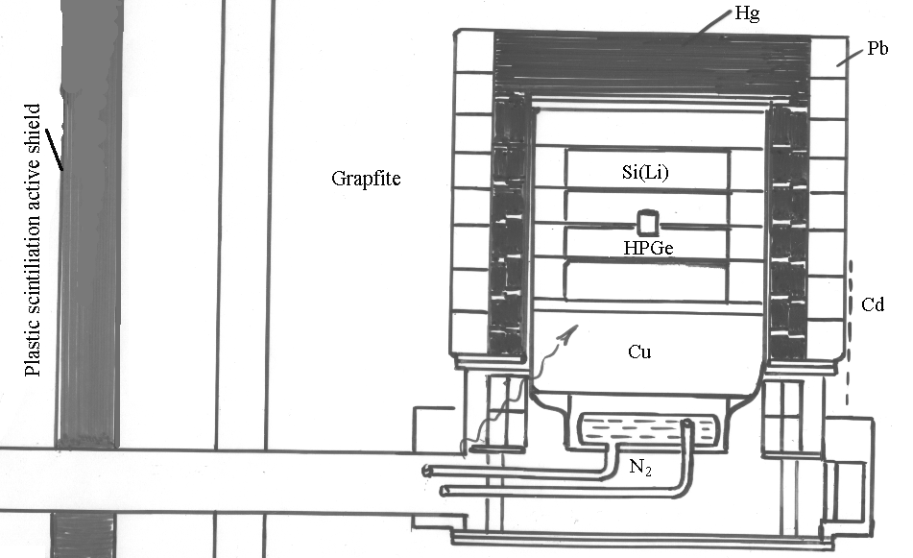

Fig.1. The experimental set. It is shown position of the silicon matrixes in vacuum cryostat, cooled by liquid nitrogen, outer heavy passive shielding, graphite shielding and 4$π$ active scintillation shield. The detector electronics is placed on the level of the nitrogen-cooling bath. HPGe detector 650g of mass is placed in the center of the detector.

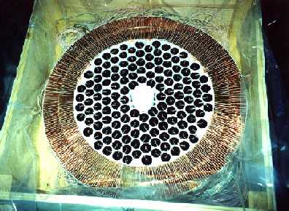
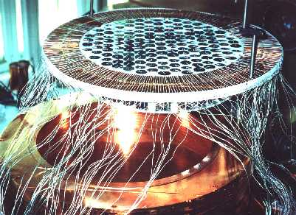
Fig.2. 1- the spectrum of scatted electrons due to $({\tilde{ν}}_{e},e)$- weak interaction;
2 - the same due to magnetic moment for $Φ_{\tilde{ν}}=2\text{.}2×{\text{10}}^{\text{13}}{\tilde{ν}}/{{\text{cm}}^{2}}⋅\text{sec}$;
3 - the background of 250g Si(Li) detector in Ge shielding - deep underground measurement;
4 - the same for 620g HPGe detector;
5,6 - the same as 1,2 for $(ν_{e},e)$ from chromium source Q =1${\text{10}}^{\text{17}}\text{decay}\text{/sec}$;
7 - weak scattering of solar neutrino.

Photo 1. This is HPGe detector in the middle of the silicon matrix. It's seen the signal and high voltage wires drowned in stepped slits of the copper shield.

Photo 3. The process of the silicon matrix montage in the inner copper shield.

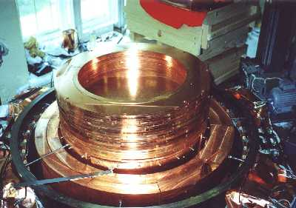
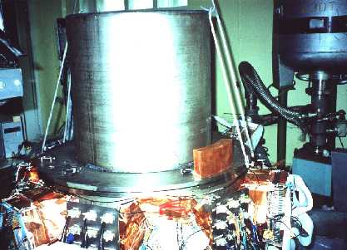

Photo 2. The electroplated inner copper shield 800-mm of the diameter is shown.

Photo 4. This is an outer view of the neutrino detector. The preamplifiers, high voltage filters and tests generator inputs situated in the bottom part of the chamber it is seen.

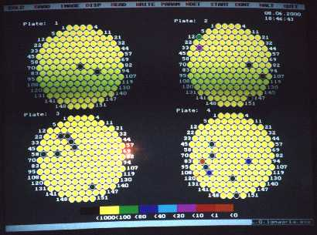

Photo 5. The display of the date representation of 604 detectors. The intensity of the accumulate events is presented by colours for the intensity ranges. Energy spectrum of any detector can be chosen and displayed so as total one.

